Activity 4.2: Social media sign up
Create a program that tells the user whether or not they are old enough to use social media.
You need to be 13 to use social media. If the user is 13 or older, the cat should say You are old enough to sign up to social media.
If the user if not 13 or older, the cat should say You are not old enough to sign up to social media.
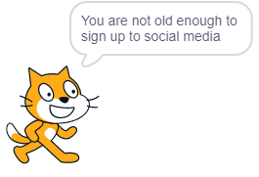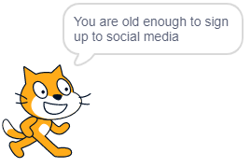
This is the output when the user enters This is the output when the user enters 15 12

Here is an example of how you can use selection in Scratch to do one thing if the condition is True and another if it is False:
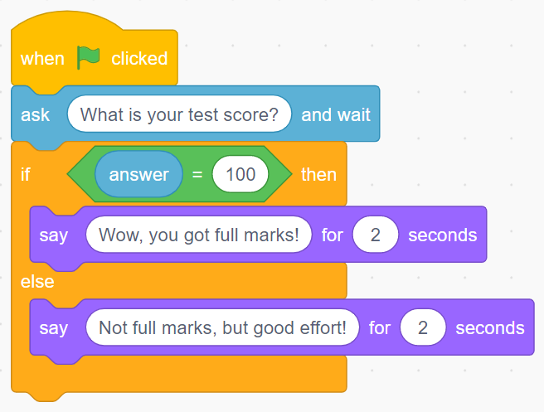
Don’t forget to screenshot your blocks and paste the screenshot into your evidence document.

